# Trustcheckr assignment.

Task:

Implement a flight search functionality. You have a form where a user can input and search for flights. Then the user can see the search results, User can refine the search using search slider for prices(UI mockup will be given below).

# Problem statement:

* Create a sample flight data with the following information
  + Name
  + Origin city
  + Destination city
  + Departure date
  + Return date
  + Departure time
  + Arrival time
  + Price
* Take the user input from the search form and perform a search on the flight data and display the valid search results.
* *Feel free to use React JS and UI frameworks like Material-ui etc.*
* **Make the webpage responsive i.e device friendly(mobile, desktop).**
* **Creativity in terms of look and feel of the page.**
* There will be two tabs for return and one-way search.
* Code structure and organization is important. Write clean code.

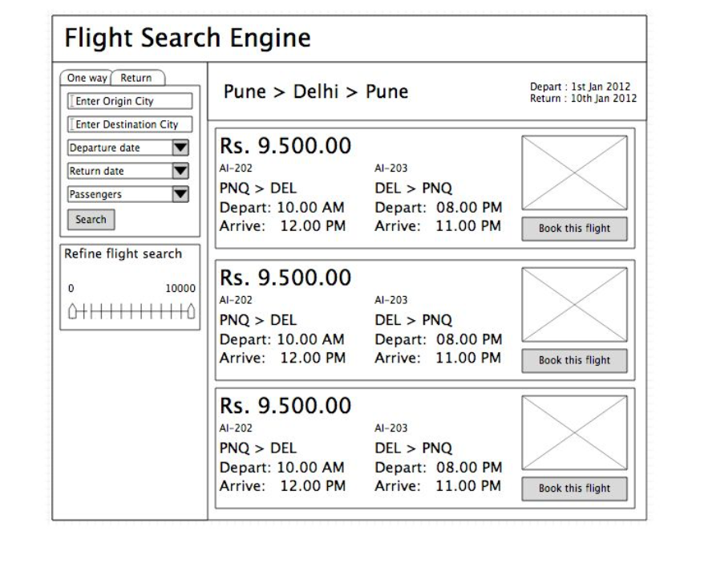

**Note**: This is just a low level representational image for your reference. Do not replicate the same UI as in the image. Create the page with brilliant look and feel. Feel free to put your creative thoughts into building the UI.